**Week01Assignment– Due 8/27/ by 8 pm. For this assignment, please e-mail the files (this word file and the excel file) directly to me (**[**kathleen.torkko@cuanschutz.edu**](mailto:kathleen.torkko@cuanschutz.edu)**). In future, assignments will be uploaded to Canvas. This assignment is worth 10 pts if you had it in in time.**

*Save your files using your last name and first initial (e.g., TorkkoK_Week01AssignmentDueAug27).*

Reading for Weeks 1 and 2 (see canvas folder)

Your Name:___________________________________________________________________________

Tell me which graduate program you belong to and what degree you are going for:

______________________________________________________________________________________

Degree: PhD_____ Masters_____ Other:_____ None:_____

What is your e-mail address?_______________________________________________________________

What statistical packages (e.g., R, Prism, SAS) have you used before, if any?

_______________________________________________________________________________________

Tell me what you expect from the class (e.g., specific types of data analysis):

Mac or PC? Mac_____ PC______

Do you need a copy of GraphPad Prism 8? Yes _____ No_____

***If you check yes, I will add your name to the list on the GraphPad website and you will receive an e-mail from GraphPad that will give you access to a temporary student license for use during the class. If you have an earlier version of Prism, please ask for a ver 8 license as there are differences between the versions.***

Rank TA office hours 1 (best) to 4 (worst)

Monday 1-2_____ Monday 2-3_____ Monday 3-4_____ Tuesday 9-10_____

Other best time___________ Time(s) above you can’t make __________________

Rank Dr. Torkko office hours 1 (best) to 4 (worst)

Wednesday 2-3_____ Wednesday 3-4_____ Thursday 2-3_____ Thursday 3-4_____

Other best time___________ Time(s) above you can’t make __________________

***The following information will be used in class only as examples for teaching purposes. No personal identifiers will be used. If you are uncomfortable providing any of the answers, please leave the answer blank.***

Age: __________

Gender: ___________

Height (inches or feet and inches): __________

Father’s height: ___________

Mother’s height: __________

Your shoe size: __________

How long is your commute to campus (on average in minutes): _____________

Are you a dog or a cat person? Dog____ Cat____ Both_____ Neither_____

Coffee or tea? Coffee______ Tea______ Both_____ Neither______

Born in Colorado? Yes___ No___

How many years have you lived in Colorado? __________

Pick a number between 1 and 100 (inclusive) __________

Day (not date) of birth (i.e., 23) _______

How many brothers and sisters do you have? __________

Pick a number between 1 and 10 (inclusive) _________

Have you taken a statistics class before? Yes_____ No_____

**Generating Random Samples (enter results in Week01 Excel file provided)**

You will generate some random samples using the web site www.random.org. We will use the data as a demonstration in class on Wednesday when we talk about sampling. Keep your results as we may use them for future examples or assignments.

From the “Games” menu, choose “Coin Flipper”. You will roll 1 coin ten times and record if the result was heads or not (enter a “1” in the table of the excel file if you tossed a head and “2” if it is a tail; I entered a “0” in all data cells). This procedure will be demonstrated in class.

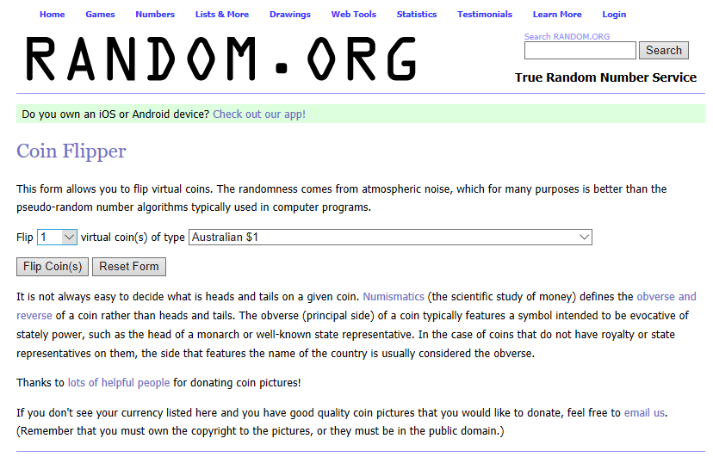 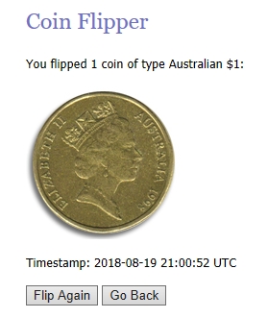

Now do two coins. (enter a 1 if they are both heads, 2 if one is a head and one is a tail, and 3 if they are both tails) Record the numbers in the excel file.

From the “Games” menu, choose “Dice roller”. You will roll 1 dice 20 times and record the total number of 1, 2, 3, 4, 5, or 6 number rolls you had. Next, repeat the procedure using 2 dice for 20 rolls. Record the dice exactly as rolled in the excel file. As you will see in the excel file, you need to count if the roll was a 2/3 or a 3/2 separately.

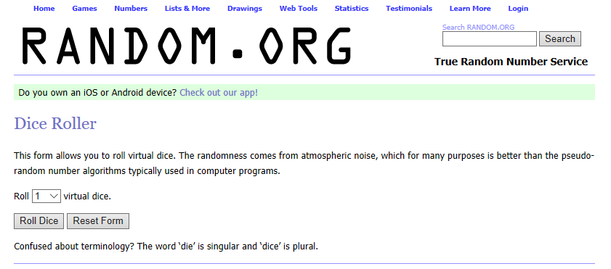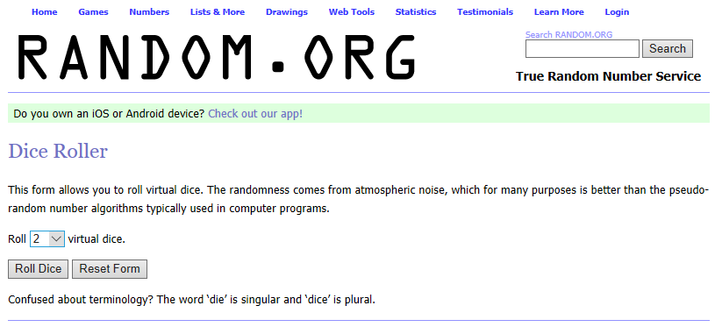

**Random Sampling**

**Proportions of colors of regular M&Ms**

Believe it or not, the proportions of colors of M&M’s are fixed at each production run. The different colors are mixed together before packaging. Each bag of M&Ms represents a random sample of M&Ms by color.



Open your personal bag of milk chocolate M&Ms. DON’T EAT UNTIL DONE WITH ALL COUNTING. Count all M&Ms by color. Enter the numbers in the table in the Excel file.

Keep your numbers handy as we may use them in future homework or lectures.